Slide 1

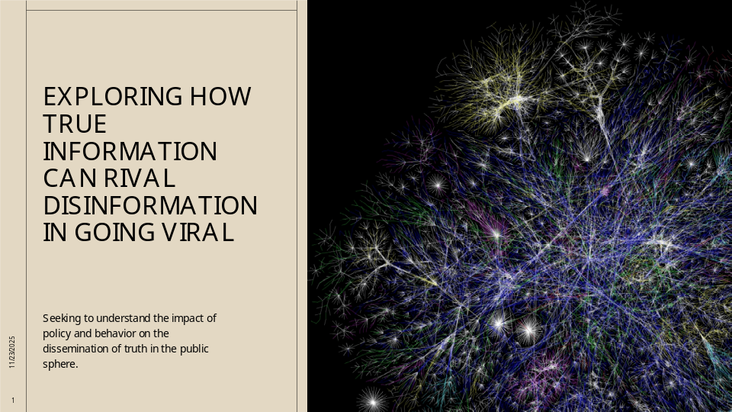

Slide 2

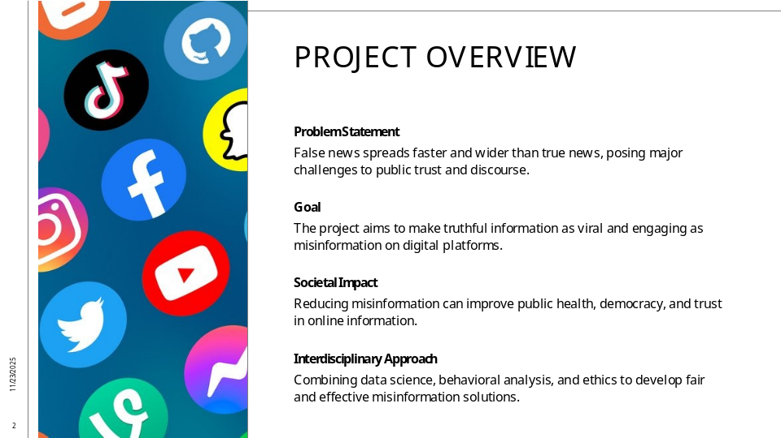

The project addresses a critical issue in the digital age: the rapid and widespread dissemination of false information compared to factual content on social media platforms. Research shows that false news spreads significantly faster and reaches more people than true news, creating challenges for public discourse and trust. The primary goal of this project is to identify strategies and mechanisms that enable accurate, truthful information to achieve virality comparable to or greater than disinformation. This involves understanding the behavioral and algorithmic factors that drive engagement and sharing, and leveraging these insights to amplify truth effectively. The societal impact of such work is profound, as it can reduce harm caused by misinformation, improve public health communication, strengthen democratic processes, and enhance trust in digital platforms. By making truth as compelling and shareable as lies, this project aims to foster a healthier information ecosystem where reliable content thrives and manipulative narratives are marginalized. The research draws on interdisciplinary approaches, combining data science, behavioral analysis, and ethical considerations to develop actionable solutions for combating misinformation while promoting transparency and fairness.

Slide 3

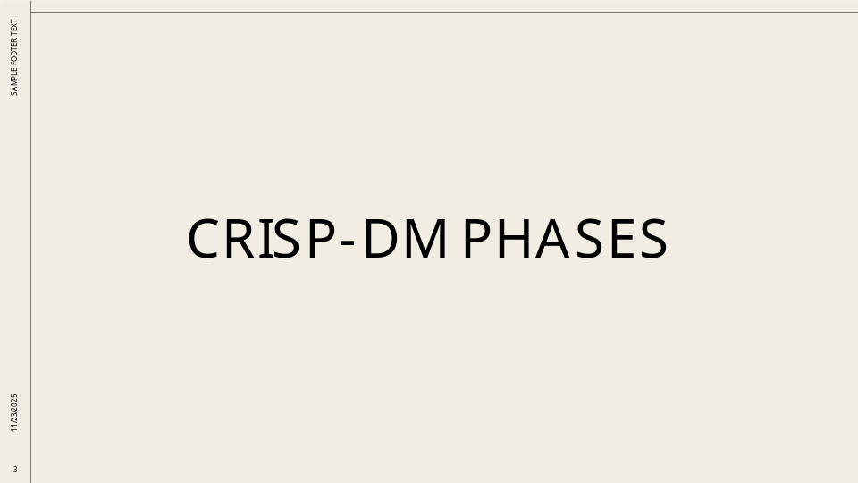

Slide 4

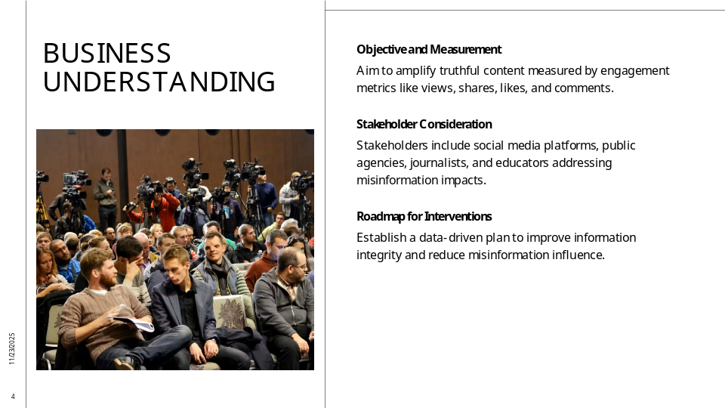

The business understanding phase focuses on defining the core problem: truthful information is often overshadowed by viral falsehoods on social media. The objective is to discover mechanisms that amplify truth effectively, ensuring that accurate content can compete with sensational disinformation. Success will be measured by engagement metrics such as views, shares, likes, and comments for truthful posts matching or exceeding those of false narratives. This phase also considers the broader implications for stakeholders, including social media platforms, public agencies, journalists, and educators. By framing the challenge in terms of measurable outcomes and societal benefits, this phase establishes a clear roadmap for subsequent data-driven interventions aimed at improving information integrity and reducing the influence of misinformation.

Slide 5

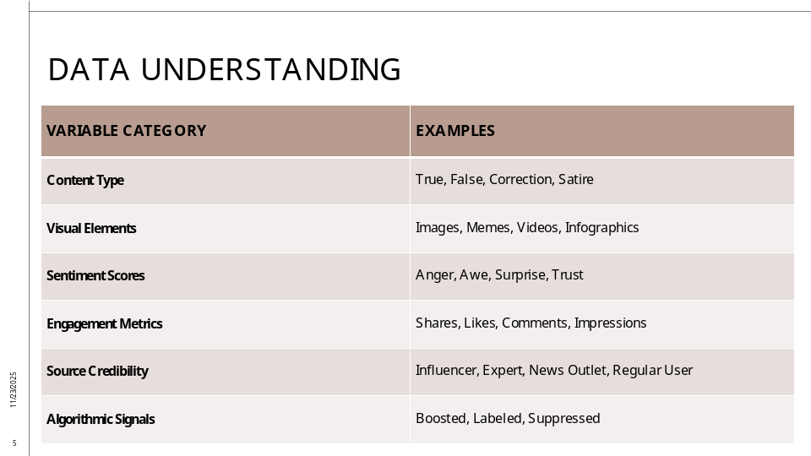

Data understanding involves identifying and sourcing the variables necessary to analyze the spread of true versus false information. Key data sources include social media APIs (Twitter/X, Facebook, Reddit, YouTube), fact-checking organizations (Snopes, PolitiFact), and academic datasets such as MIT’s False News dataset. Essential variables encompass content type (true, false, satire), visual elements (images, videos), sentiment and novelty scores, engagement metrics (shares, likes, comments), source credibility indicators (account type, verification status), and algorithmic signals (boosted, labeled, suppressed). Additional factors include user exposure to prebunking or media literacy interventions. Understanding these variables provides a foundation for modeling virality dynamics and designing strategies to enhance the reach of truthful content.

Slide 6

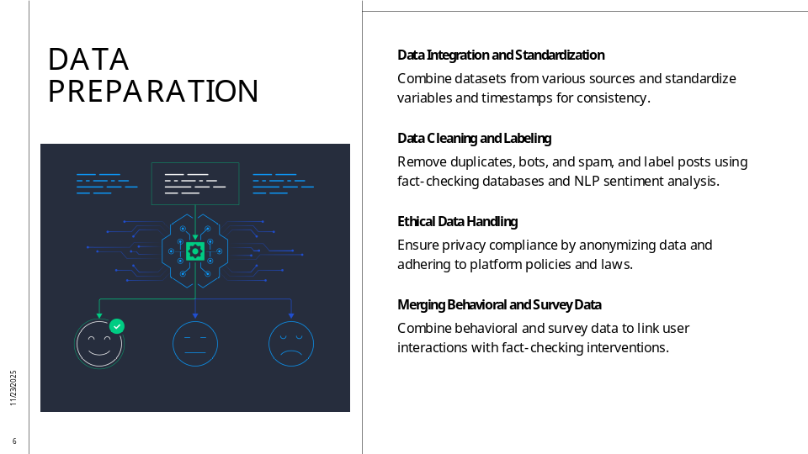

Data preparation entails integrating datasets from multiple platforms, standardizing variables and timestamps, and normalizing engagement metrics. Posts will be labeled using fact-checking databases, while natural language processing models will assess sentiment and novelty. Cleaning processes include removing duplicates, bots, and spam, and handling missing data through imputation or exclusion. Ethical considerations are paramount, ensuring compliance with privacy laws and platform policies while anonymizing personally identifiable information. This phase also involves merging behavioral and survey data to provide a comprehensive perspective on user interactions and linking these insights to fact-checking interventions. Proper preparation ensures data integrity and reliability, which are critical for accurate modeling and analysis.

Slide 7

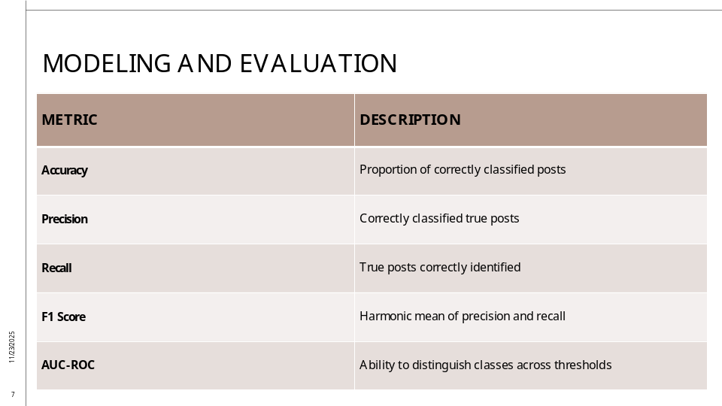

The modeling phase employs classification algorithms such as logistic regression, decision trees, support vector machines, and deep learning to distinguish between true and false posts. Regression and survival analysis predict virality and speed of spread, while clustering and network analysis uncover patterns and influential actors. Evaluation metrics include accuracy, precision, recall, F1 score, AUC-ROC for classification, MAE and RMSE for regression, and C-index for survival analysis. Cross-validation and resampling techniques mitigate overfitting and address class imbalance. These models aim to provide actionable insights into the factors driving virality and inform strategies for amplifying truthful content effectively.

Slide 8

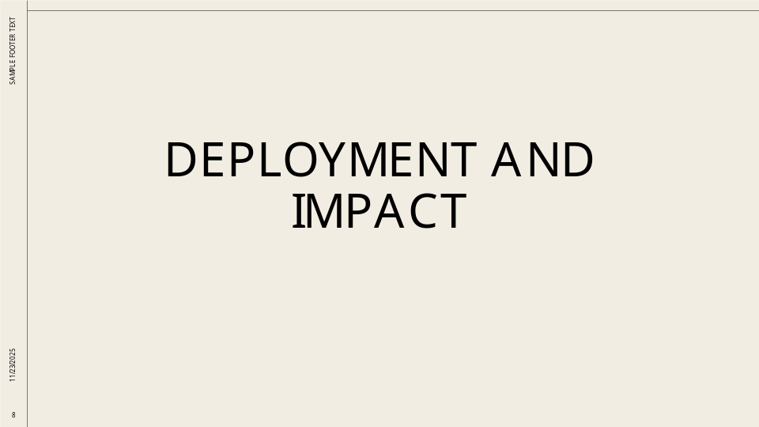

Slide 9

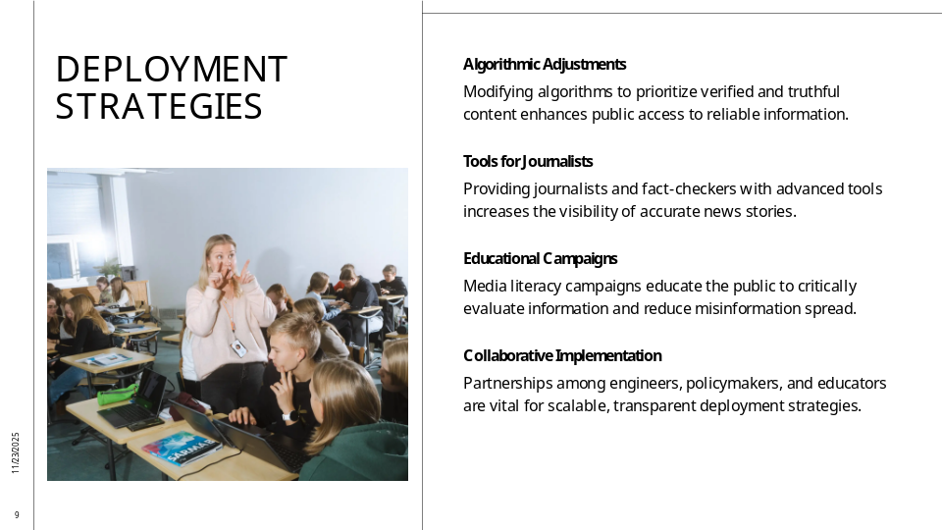

Deployment involves integrating research findings into social media platforms, public agencies, and newsrooms to amplify truthful content. Strategies include algorithmic adjustments to boost verified information, tools for journalists and fact-checkers to enhance visibility, and educational campaigns to improve media literacy. These interventions can support public health messaging, emergency communications, and democratic discourse by ensuring accurate information reaches audiences quickly and effectively. Collaboration with platform engineers, policymakers, and educators is essential to implement these solutions at scale and maintain transparency and trust.

Slide 10

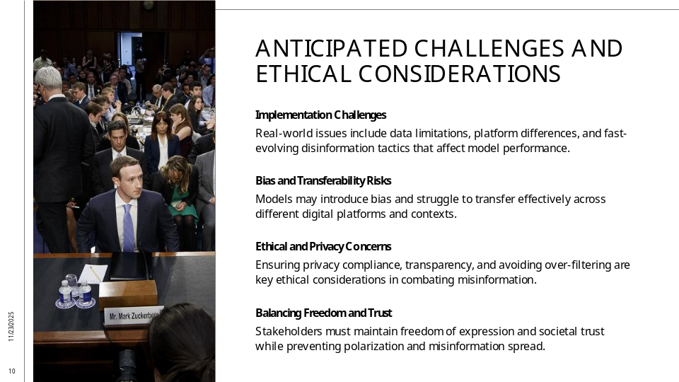

Several challenges may arise during real-world implementation, including data limitations, platform-specific differences, and rapidly evolving disinformation tactics. Models may struggle with transferability across platforms and risk introducing bias. Ethical concerns include privacy compliance, transparency, and avoiding over-filtering that could suppress legitimate discourse. Continuous monitoring and adaptation are necessary to address emerging threats and maintain fairness. Stakeholders must balance intervention strategies with freedom of expression and societal trust, ensuring that efforts to combat misinformation do not inadvertently amplify polarization or erode confidence in digital platforms.

Slide 11

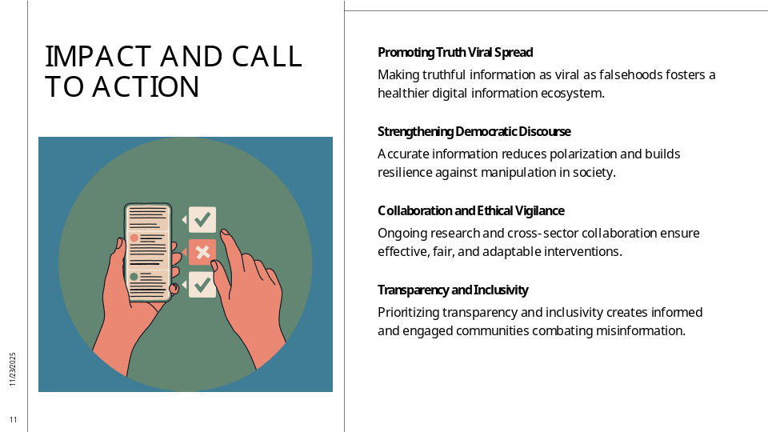

Successfully making truth as viral as falsehoods represents a transformative step toward a healthier information ecosystem. This achievement would strengthen democratic discourse, reduce polarization, and build resilience against manipulation. The project underscores the importance of ongoing research, ethical vigilance, and cross-sector collaboration to ensure that interventions are effective, fair, and adaptable to changing digital landscapes. By prioritizing transparency and inclusivity, stakeholders can create a more informed and engaged society where accurate information thrives and misinformation loses its grip.

